Iphone photo backup suggestions ny times

October 8, 2025

Our best advice: Skip the portable SSD and choose two of the four backup methods we discuss below instead. That way, even if one fails, your precious photos remain protected. And if you need advice on managing and organizing your photos, we’ve got you covered there as well.
Advertisement
SKIP ADVERTISEMENT
The easiest, fastest method
Top pick



Set-it-and-forget-it backup
Apple iCloud+
iCloud Photos offers easy and automatic backup for every snapshot and picture you take.
Buy from Apple
The easiest way to back up iPhone photos is to use Apple’s iCloud Photos service, which is built into every iPhone. The free version holds 5 GB (about 1,500 photos), which doesn’t last long in the age of social media. However, you can upgrade to Apple iCloud+, which allows storage ranging from 50 GB (15,000 photos) for $1 per month up through a few tiers to 12 TB (millions of photos) for $60 a month — such high capacity is better suited for professional photographers, video-shooting influencers, or large families who have multiple devices per person.
iCloud and iCloud+ are automatic: Once you set them up, they back up the data, settings, photos, and videos on your phone in the background. They store original photos at full resolution, complete with EXIF information such as the GPS location, date, and camera settings.
iCloud Photos keeps your original photos intact both on your iPhone and in its cloud-based storage by default. However, if you’re running out of storage space on your iPhone, you can turn on a feature called Optimize Storage, which keeps only smaller thumbnails on your iPhone while the original versions still live in the cloud.
If you use the Optimize Storage setting, every time you want to closely look at a photo you haven’t viewed in a while, you have to tap the thumbnail and wait for the original photo to redownload to your iPhone over Wi-Fi or a potentially slow cellular signal.
It’s important to remember that when (or if) you delete videos or photos on your iPhone, that means you’re deleting them from the iCloud backup too, though you have 30 days to retrieve them from the trash can if you deleted them by mistake. Using Optimize Storage, however, gives you more space for images on your phone.
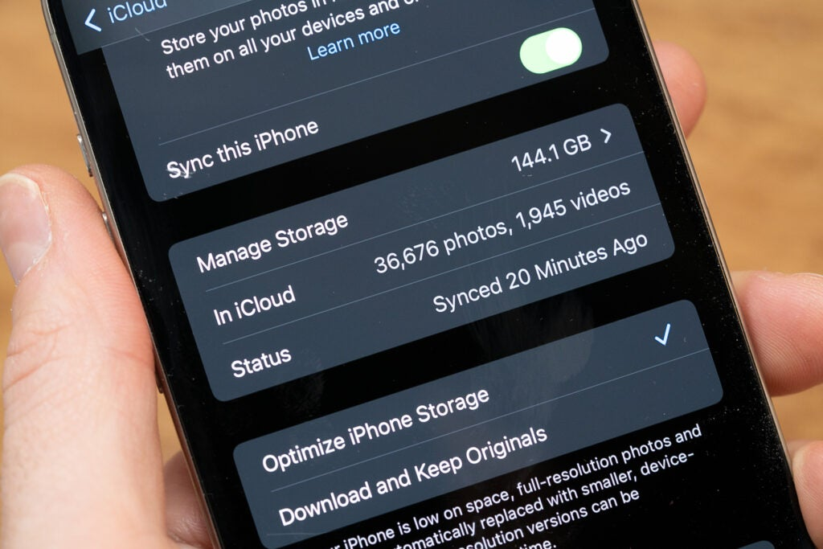
Michael Hession/NYT Wirecutter
iCloud Photos also backs up hidden and locked albums and keeps all albums intact, providing better organization than what you’d get by simply copying the photos to a portable SSD or hard drive.
Once you back up your photos, you can view them on most devices. You can access them from the Photos app on your iPhone or iPad, the Photos app on your MacBook, your Apple TV, or any PC or Chromebook via a web browser.
We think this is the easiest and most complete backup method for iOS devices, as long as you’re willing to subscribe if you have more than 5 GB of photos. But some people might be wary of storing all of their photos on Apple’s servers. If you have such concerns, we recommend taking the portable SSD route or using the Mac backup method detailed below.
Back up to a Mac
If you don’t want to manually select individual photos to back up to an external drive, and you want a little more security, you can back up your entire iPhone to your Mac. We don’t recommend buying an iMac, Mac mini, or MacBook just for this purpose, but if you already own one, backing up your devices to it is pretty simple.
Your Mac has a feature called Time Machine, which you can use to automatically back up your computer to a portable SSD or external hard drive. You can enable Time Machine by going through these steps:
- Connect the portable SSD or external hard drive to your MacBook.
- Open System Settings > General > Time Machine.
- Click Add Backup Disk.
- Select the name of the drive and click Set Up Disk.
- Setup may ask you for permission to format or erase the disk to prepare it for Time Machine, but once that’s done, it is ready to back up your MacBook automatically while the drive is connected.
After the Time Machine backup is set up, connect your iPhone to the Mac with a USB-C cable, and follow these steps:
- In the Finder, locate your iPhone’s name and click it.
- At the top of the window, click General.
- Select Back up all of the data on your iPhone to this Mac.
- Click Back Up Now.
Once your iPhone is backed up to your Mac, the Time Machine drive will save that backup automatically.
This Time Machine backup, like iCloud (more on that below), offers another benefit, as it allows you to recover your entire iPhone at once if you get a new phone. Most folks who have upgraded their iPhone in the past few years have been able to transfer the photos and files wirelessly from their old phone to the new one, but using a USB-C cable and a Mac can be faster and (theoretically) more secure. This is the method we recommend if you don’t want to use any cloud-based methods that save your photos to someone else’s computer servers.
Use another cloud storage service
Runner-up

Back up to the backup
Google One
While not as comprehensive as Apple’s built-in service, Google Photos is just as easy to use.
Buy from Google

Back up to the backup
Microsoft OneDrive
Microsoft’s OneDrive is another easy-to-use photo backup, in case you’d rather use a different service.
Buy from Microsoft
You can use Google Photos or Microsoft’s OneDrive to store iPhone photos just as easily as you can with iCloud; you just need a Google account or a Microsoft 365 account, respectively. You may already be paying for one of these services, and utilizing that existing storage can be more economical than paying for a new iCloud+ account. One other benefit of Google Photos (but not OneDrive): If your family owns other Google devices, such as Android phones, Google TVs, or Google Nest Hubs, your photos will sync to, and can display on, those devices as well.
After you’ve backed up your photos to Google Photos or OneDrive, you can choose to save space on your phone by using the “clean up space” option in Google Photos or by deleting the photos from your camera roll manually if you’re using OneDrive. If you decide to do this, be careful: In contrast to the Optimize Storage option in iCloud Photos, no thumbnails will remain in your camera roll, so recovering photos to your camera roll from your Google Photos or OneDrive storage back to your iPhone is a manual process.
Like iCloud Photos, both Google Photos and OneDrive offer iPhone apps and web access to your photos and albums.
Neither service is a vault that you can store stuff in and forget — you have to keep using it. Google Photos, in particular, will deactivate and delete your stored photos and files if your account is idle for two years.
The bottom line
We wish it were easier to move albums directly from your iPhone to an external storage drive, but until Apple’s photo-management tools give you more control over file exports, your built-in iCloud storage is the easiest way to back up your photos. If you don’t want to pay for more iCloud space, or if you don’t want your photos stored in the cloud, backing up to your Mac is another solid option.
In the meantime, may we suggest deleting some photos? Parting ways with all those duplicates and screenshots will certainly free up space.
This article was edited by Signe Brewster and Caitlin McGarry.

