Matt server webpages open excel files on laptop.
February 21, 2026

[ excel files could be on server, and maybe on laptop, but opened from a link stored in a webpage on the servers. Confusing.. but maybe important to me. ]

Matt,

This is something interesting I ran into tonight. You don’t need to look at it anytime soon. I will call you about it sometime and you can look at it then

xxxxxxxxxxxxx
Rather than have you read through my long interaction with Claude I will try to be brief here. I would like to talk to you about this sometime. It implies that I could have something like a file (e.g. excel or word) stored on my server in a folder and then open it on my laptop in its parent program (excel or word) on my laptop. It does this now with .mp3 and .pdf, and .mp4, but not .docx or .xlsx.

This also implies I could have a link in webpage on the server that was a full file path to a file on my laptop and be able to have the webpage open that link on my laptop (file:url… see my stored note)

I wanted to get a list of words in a certain order from Claude (for Spellingbee) in a column that I could paste into excel. It said it could give me a .csv file. It did :

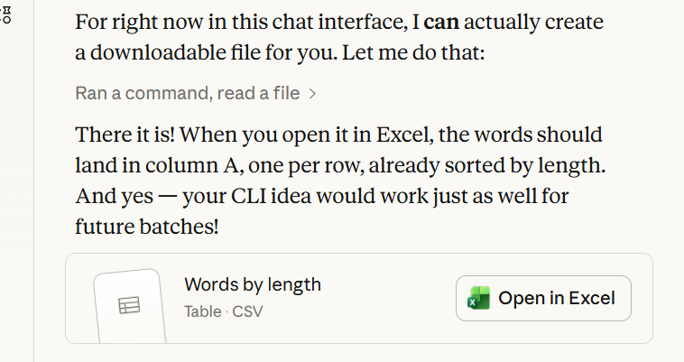
When I clicked the “open” in Excel button the column (miraculously to me) opened in my open Excel document. Say what!

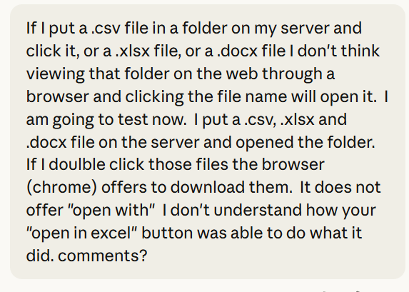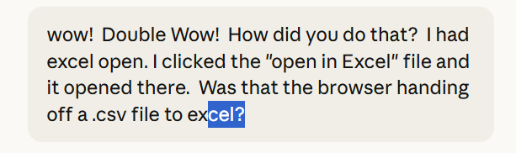

Great experiment — you're thinking like a wombat systematically testing every tunnel!
The key difference is where the file lives:
When you click a file on your server through a browser, Chrome is acting as a remote file fetcher — it downloads the file and offers you "save or open" choices based on your OS settings, but it's a two-step process.
What happened with my "open in Excel" button is different — that file was delivered through the Claude.ai interface infrastructure, which likely sends the file with specific HTTP headers like Content-Disposition: attachment along with the proper MIME type (text/csv). Claude.ai's servers are configured to serve these files in a way that triggers your browser's built-in file association handling more directly.
Also importantly — your Windows file associations for .csv may be set to auto-open with Excel when downloaded from a trusted source like Claude.ai, whereas your own server might not be sending the right MIME type headers, causing Chrome to be more cautious and just offer a download.
To make your server behave the same way you'd need to configure it to send the right Content-Type headers with the files. For Apache or Nginx that's usually just a configuration tweak.
But honestly — the exact mechanism Claude.ai uses internally is a bit of a black box even to me! I know what I asked the system to do, but the delivery pipeline is handled by Anthropic's infrastructure. It clearly works nicely though!
Very interesting. We will explore this at another time. thanks
Sonnet 4.6

