Home screen changes
The current non-scrolling header area will become two lines. The first one small like the current font of the “BOPLIST” text.
Below that will appear “Home Screen” in larger letters and icon or graphic for a home – this might be too distracting but
let’s try it:

The center area will be the current “Crete New List” button. I want to make that look more like a button, maybe put lines around the box with curved corners, or maybe something like this
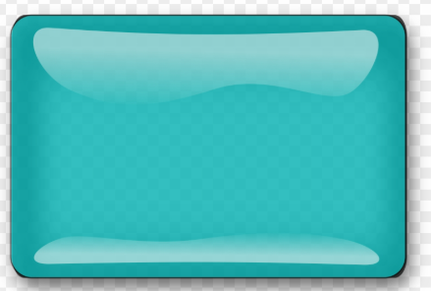

This is really the only important button in the header area. I don’t think the “print list names” should be as large, though I also want to be sure it has a button look.

The revision and rev data can be kept small, put on two lines and put at the left of the screen.

Pretty good. Iwant to reduce the “Home Screen” about 25%. I want to free up as much vertical space as possible as long as the header area does not look to tight. Move the “Create… “ button a little to the left” To the right of the “Create “ button will be two horizontal areas. The top one will be the small revision info, Maybe on two small lines. Below that will be the print button. Make the print look more like a button and move it to the left, closer to the “create “ button.

Try a black line around the edges of the buttons to see if that makes them more like a button

Too tight. Move the “create ..” button about ½” to the right. Move the rev data and print names to about 1/2” further away from the “Create …” button and put the rev data on one line.

If you put black lines around the button they do not show with the black background. They would have to be a little inside the button. I don’t care that much about that on this screen.

Move the Note button to be next to the “view list” button in the actions column. I think that puts them in the order of my desired/estimated order of frequency.

Xxxxxxxxxxxxxxxxxxxxxxx
The list entries screen header will look similar to the header on the home screen. Same size “boplist” text and the “List Entries” screen title the same size as the “Home screen” text. In place of the home icon on the home screen, put in the list_and_pen.png graphic. It is in the same folder as the home.icon was, boplist_dev.

xxxxxxxxxxxxxxxxxxxxxxxxxxxxx
Now comes the more significant changes. I want to set up the lists to be able to have entries that are list.

Every list can have three possible natures:
A parent (meaning that one or more of its en

